**Spreadsheets - Manipulate Data (Second Week)**

## SUBSTITUTE

**Text String**: String of letters, numbers, and punctuation that is not treated numerically.

While the SUBSTITUTE function sounds similar to find/replace, it is used for different purposes. Find/replace gets rid of the old data, while SUBSTITUTE will not change the original cell, instead showing the transformed data in a new cell.

SUBSTITUTE uses the syntax SUBSTITUTE({text}, {old_text}, {new_text}), where {text} is the cell to change, {old_text} is the string sequence to be replaced, and {new_text} is the new string in place of the old one.

## Extract Text

FIND and LEFT can be used to extract text. FIND can be given a substring and a cell to return the position in a string where the substring was found. LEFT can then be used to extract a certain number of characters from a cell, starting from the left side.

RIGHT therefore extracts from the right side, while MID can extract from some starting point in the middle of a cell.

MID(text, start_num, num_chars)

text

text string containing the characters you want to extract

start_num

position of the first character you want to extract in text

num_chars

the number of characters you want MID to return from text

FIND(find_text, within_text, [start_num])

find_text

the text you want to find

within_text

the text containing the text you want to find

start_num

OPTIONAL - character position at which to start the search

## Reformat Text

CONCATENATE will join together two or more strings. It's important to note that this will not automatically add spaces between them, so make sure to add spaces as formula parameters if you need them.

TRIM will help to remove excess whitespace from a string.

PROPER sets the first letter of each word to upper case, with the rest lowercase.

UPPER sets all letters to upper case, while LOWER sets all letters to lowercase.

**Math Functions**

Math operations are one of the most common spreadsheet usages. These are used similarly to what one might expect (with a leading equals sign):

* + for addition
* - for subtraction
* * for multiplication
* / for division

There are also the functions SUM and AVERAGE, which behave as their names suggest - summing or averaging two or more cells, numbers or a range of cells.

## Duplicate Rows

**Clean Data**: Data that is free of corrupt or inaccurate data items.

In Excel, under the Data tab, you can use the "Remove Duplicates" feature to remove duplicated values.

### Google Sheets Help

If you are using Google Sheets as your Spreadsheet app, there is an add-on called [Remove Duplicates](https://workspace.google.com/u/0/marketplace/app/remove_duplicates/347814268012). Once the add-on is installed, remove the duplicates by highlighting the columns and selecting "Add-ons->Remove Duplicates".

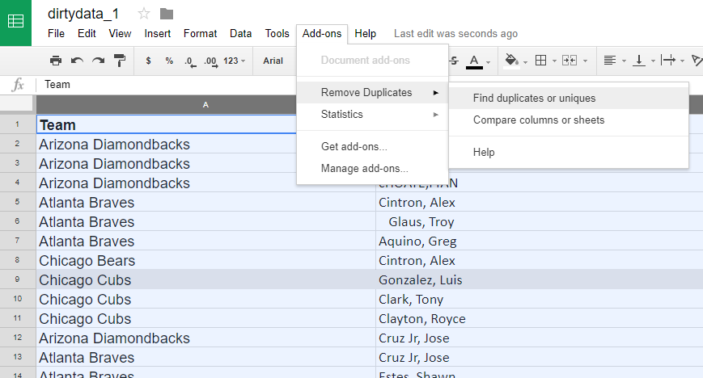

Using the "Remove Duplicates" add-on

## Split Columns

Splitting data is useful when you have data such as first and last names, or City and State, separated by a delimiter (such as a comma). In Excel, this can be done by adding a column to the right of the one you want to split, and then in the Data tab, selecting "Text to Columns".

Make sure you add the extra column first, as existing data may otherwise be overwritten in the next column otherwise.

Splitting data is useful when you have data such as first and last names, or City and State, separated by a delimiter (such as a comma). In Excel, this can be done by adding a column to the right of the one you want to split, and then in the Data tab, selecting "Text to Columns".

Make sure you add the extra column first, as existing data may otherwise be overwritten in the next column otherwise.

## Sort Data

Sorting is a very useful feature of spreadsheet applications. Select all your data, then on the Data tab, click the "Sort" button. You can also choose which column to sort on, or even multiple columns.

## Filter Data

**Filter**: A method to group data by selecting characteristics of one or more columns of a data set.

The filter method is used by clicking on the filter button, which has a little filter as its icon. You can then select which items you want to filter down to. Make sure if you want to use a filter on multiple columns that you clear old column filters no longer needed.